1. Use all-subsets regression.
2. **Report the variables in the best model of each size.**

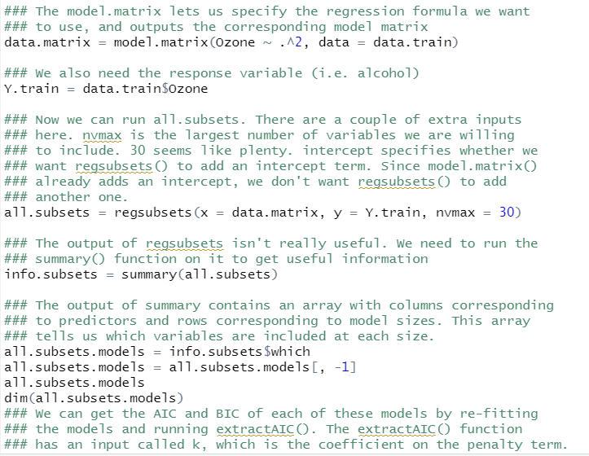

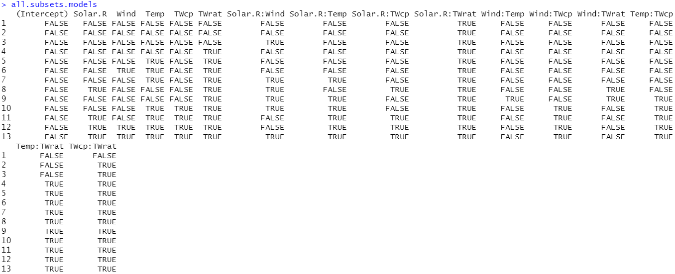

(b) Compute BIC on each of these models and **report the BIC values for the**

**models.**

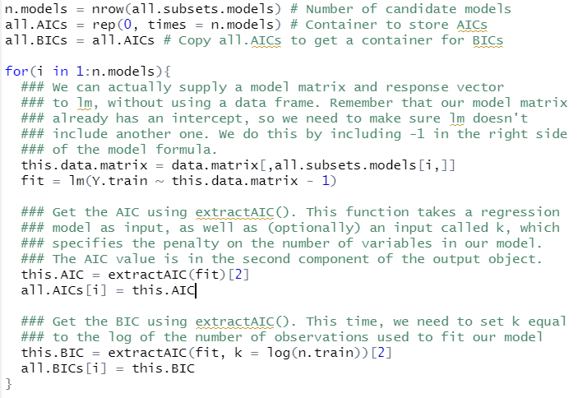

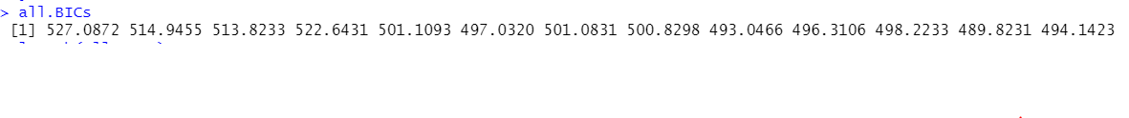

(c) Identify the best model. **What variables are in it?**



12th model includes "Solar.R", "Wind", "Temp", "TWcp", "TWrat", "Solar.R:Temp", "Solar.R:TWcp" "Solar.R:TWrat", "Wind:TWcp", "Temp:TWcp", "Temp:TWrat", and "TWcp:TWrat"

2. Use the hybrid stepwise algorithm that is the default in the step() function. **Report**

**the model that it chooses as “best.”**

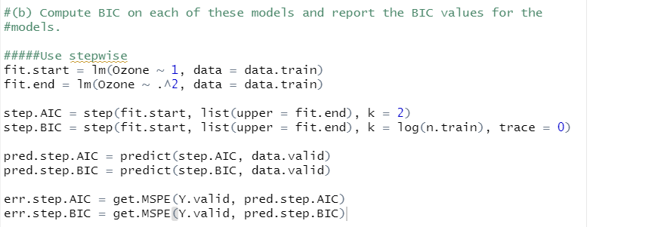

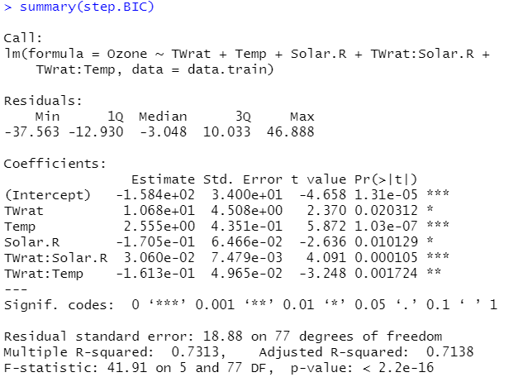

The model that use TWrat, Temp, Solar.R, TWrat:Solar.R, and Twrat:Temp as variables

3. Use 10-fold CV to estimate the MSPE for the stepwise model selection process. That

is,

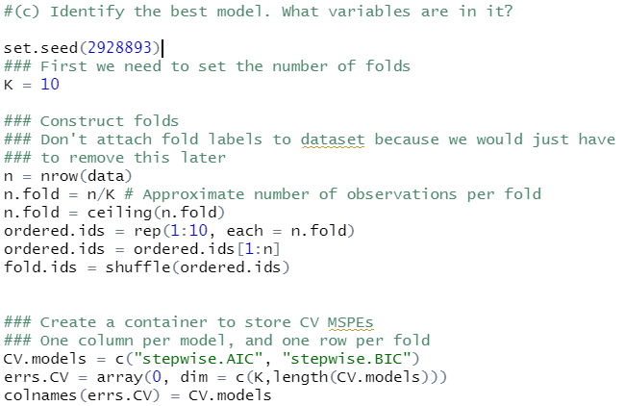

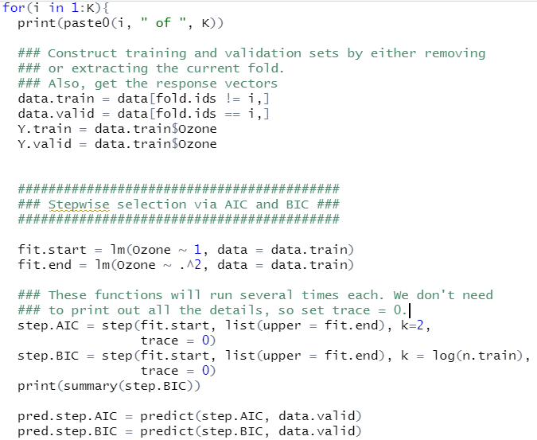

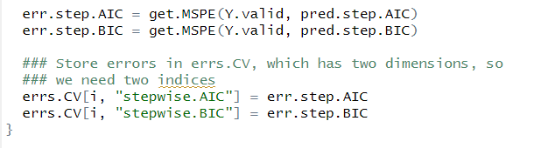

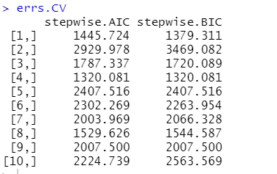

4th model shows the smallest BIC with 1320.081.